Department of CSE-IOT

Vision of the Department
To be a preferred hub for nurturing computer engineering aspirants through innovative, ethical, value-based technical education, impactful research, and industry collaboration, to become successful professionals contributing for the betterment of society.

Mission of the Department
To nurture computer engineering professionals by offering: Dynamic learning environment that encourages problem-solving using emerging technology, · National Education Policy aligned evidence-based technical education, fostering innovation, research, and industry–institute
collaboration, Holistic, ethical and sustainable development for lifelong success.

Session 2025-2026(EVEN)
Mission: Means to achieve Vision
Vision: Dream of where you want.
Program Educational Objectives of the program (PEO): (broad statements that describe the professional and career accomplishments)
PEO1 | Preparation | P: Preparation | Pep-CL abbreviation  pronounce as Pep-si-lL easy to recall
PEO2 | Core Competence | E: Environment (Learning Environment)
PEO3 | Breadth | P: Professionalism
PEO4 | Professionalism | C: Core Competence
PEO5 | Learning  Environment | L: Breadth (Learning in diverse areas)

Program Outcomes (PO): (statements that describe what a student should be able to do and know by the end of a program)

Keywords of POs:
Engineering knowledge, Problem analysis, Design/development of solutions, Conduct Investigations of Complex Problems, Engineering Tool Usage, The Engineer and The World, Ethics, Individual and Collaborative Team work, Communication, Project Management and Finance, Life-Long Learning

PSO Keywords: Cutting edge technologies, Research

“I am an engineer, and I know how to apply engineering knowledge to investigate, analyse and design solutions to complex problems using tools for entire world following all ethics in a collaborative way with proper management skills throughout my life.” to contribute to the development of cutting-edge technologies and Research.

Integrity: I will adhere to the Laboratory Code of Conduct and ethics in its entirety.

Anushka Yede

06-03-2026

Name and Signature of Student and Date
(Signature and Date in Handwritten)

Department of CSE-IOT

Vision of the Department
To be a preferred hub for nurturing computer engineering aspirants through innovative, ethical, value-based technical education, impactful research, and industry collaboration, to become successful professionals contributing for the betterment of society.

Mission of the Department
To nurture computer engineering professionals by offering: Dynamic learning environment that encourages problem-solving using emerging technology, · National Education Policy aligned evidence-based technical education, fostering innovation, research, and industry–institute
collaboration, Holistic, ethical and sustainable development for lifelong success.

Session | 2024-25 (EVEN) | Course Name | Mobile and Web Application for IOT Lab
Semest er | 6 | Course Code | 23IOT1624
Roll No | 01 | Name of Student | Anushka Yede

Practical Number | 8
Course Outcome | - Understand and apply basic Kotlin programming constructs including variables, control structures, functions, null safety, and object-oriented concepts for Android app development.  - Design and develop responsive user interfaces using XML layout files, ViewGroups, and widgets in Android Studio, adhering to Material Design principles.  - Implement event handling and application logic using Kotlin to capture user input, manage app state, navigate between screens, and interact with Android system components like Toasts and Dialogs  - Integrate learned concepts to develop a mini Android application that demonstrates use of ViewModel, multi-screen navigation, and proper UI/UX design for real-world problem-solving
Aim | Manage UI state using ViewModel.  Tasks: ViewModel setup, LiveData, handling configuration changes.
Problem Definitio  n | Develop an Android application that maintains a counter value using ViewModel and LiveData. The  counter should increase when a button is clicked, and the value should remain unchanged even after  configuration changes such as screen rotation.
Theory (100  words) | In Android development, configuration changes such as screen rotation can cause an Activity to restart, which may lead to loss of UI data. To solve this problem, Android provides architecture components like ViewModel and LiveData that help manage UI-related data efficiently.  ViewModel is a class that stores and manages data required for the user interface. It is lifecycle-aware and survives configuration changes, which means the stored data is not lost when the device rotates or the Activity is recreated.  LiveData is an observable data holder class that allows UI components to observe data changes. When the data inside LiveData changes, the UI is automatically updated without requiring manual refresh.  In this experiment, a counter value is stored inside the ViewModel and exposed through LiveData. When the user clicks the Increase Counter button, the counter value increases and the UI updates automatically. Even if the device rotates, the ViewModel retains the counter value, ensuring that the data remains consistent and the user experience is not interrupted.

Department of CSE-IOT

Vision of the Department
To be a preferred hub for nurturing computer engineering aspirants through innovative, ethical, value-based technical education, impactful research, and industry collaboration, to become successful professionals contributing for the betterment of society.

Mission of the Department
To nurture computer engineering professionals by offering: Dynamic learning environment that encourages problem-solving using emerging technology, · National Education Policy aligned evidence-based technical education, fostering innovation, research, and industry–institute
collaboration, Holistic, ethical and sustainable development for lifelong success.

Procedur e and Executio n | Procedure and Execution (Stepwise – Aim 2)  - Open Android Studio and create a new Android project.  - Add the required Android Architecture Components dependencies such as ViewModel and LiveData.  - Create a ViewModel class to store the counter value.  - Use LiveData inside the ViewModel to hold and observe the counter data.  - Design the UI layout with a TextView to display the counter and a Button to increase the value.  - In the Activity, connect the ViewModel with the UI using ViewModelProvider.  - Observe the LiveData so the TextView updates automatically when the counter changes.  - Implement the button click event to increase the counter value in the ViewModel.  - Run the application and verify that the counter remains unchanged after screen rotation.
(100
Words)

Department of CSE-IOT

Vision of the Department
To be a preferred hub for nurturing computer engineering aspirants through innovative, ethical, value-based technical education, impactful research, and industry collaboration, to become successful professionals contributing for the betterment of society.

Mission of the Department
To nurture computer engineering professionals by offering: Dynamic learning environment that encourages problem-solving using emerging technology, · National Education Policy aligned evidence-based technical education, fostering innovation, research, and industry–institute
collaboration, Holistic, ethical and sustainable development for lifelong success.

Code:
2. CounterViewModel.java
package com.example.viewmodeldemo;
import androidx.lifecycle.LiveData;
import androidx.lifecycle.MutableLiveData;
import androidx.lifecycle.ViewModel;

public class CounterViewModel extends ViewModel {
private MutableLiveData&lt;Integer&gt; counter = new MutableLiveData&lt;&gt;();
public CounterViewModel() {
counter.setValue(0);
}
public LiveData&lt;Integer&gt; getCounter() {
return counter;
}
public void increaseCounter() {
counter.setValue(counter.getValue() + 1);
}
}

3. MainActivity.java
package com.example.viewmodeldemo;
import androidx.appcompat.app.AppCompatActivity;
import androidx.lifecycle.Observer;
import androidx.lifecycle.ViewModelProvider;
import android.os.Bundle;
import android.widget.Button;
import android.widget.TextView;
public class MainActivity extends AppCompatActivity {
TextView textCounter;
Button btnIncrease;
CounterViewModel viewModel;
@Override
protected void onCreate(Bundle savedInstanceState) {
super.onCreate(savedInstanceState);
setContentView(R.layout.activity_main);
textCounter = findViewById(R.id.textCounter);

btnIncrease = findViewById(R.id.btnIncrease);
viewModel = new ViewModelProvider(this).get(CounterViewModel.class);
viewModel.getCounter().observe(this, new Observer&lt;Integer&gt;() {
@Override
public void onChanged(Integer value) {
textCounter.setText(String.valueOf(value));
}
});
btnIncrease.setOnClickListener(v -&gt; viewModel.increaseCounter());
}
}

4. activity_main.xml
&lt;?xml version=&quot;1.0&quot; encoding=&quot;utf-8&quot;?&gt;
&lt;LinearLayout xmlns:android=&quot;http://schemas.android.com/apk/res/android&quot;
android:layout_width=&quot;match_parent&quot;
android:layout_height=&quot;match_parent&quot;
android:gravity=&quot;center&quot;
android:orientation=&quot;vertical&quot;&gt;
&lt;TextView
android:id=&quot;@+id/textCounter&quot;
android:layout_width=&quot;wrap_content&quot;
android:layout_height=&quot;wrap_content&quot;
android:text=&quot;0&quot;
android:textSize=&quot;30sp&quot;/&gt;
&lt;Button
android:id=&quot;@+id/btnIncrease&quot;
android:layout_width=&quot;wrap_content&quot;
android:layout_height=&quot;wrap_content&quot;
android:text=&quot;Increase Counter&quot;/&gt;
&lt;/LinearLayout&gt;

Department of CSE-IOT

Vision of the Department
To be a preferred hub for nurturing computer engineering aspirants through innovative, ethical, value-based technical education, impactful research, and industry collaboration, to become successful professionals contributing for the betterment of society.

Mission of the Department
To nurture computer engineering professionals by offering: Dynamic learning environment that encourages problem-solving using emerging technology, · National Education Policy aligned evidence-based technical education, fostering innovation, research, and industry–institute
collaboration, Holistic, ethical and sustainable development for lifelong success.

Department of CSE-IOT

Vision of the Department
To be a preferred hub for nurturing computer engineering aspirants through innovative, ethical, value-based technical education, impactful research, and industry collaboration, to become successful professionals contributing for the betterment of society.

Mission of the Department
To nurture computer engineering professionals by offering: Dynamic learning environment that encourages problem-solving using emerging technology, · National Education Policy aligned evidence-based technical education, fostering innovation, research, and industry–institute
collaboration, Holistic, ethical and sustainable development for lifelong success.

Output:
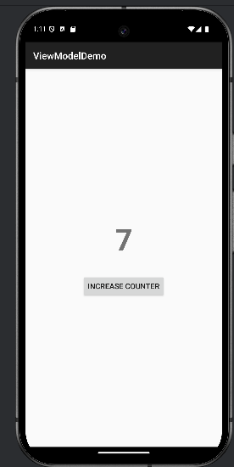

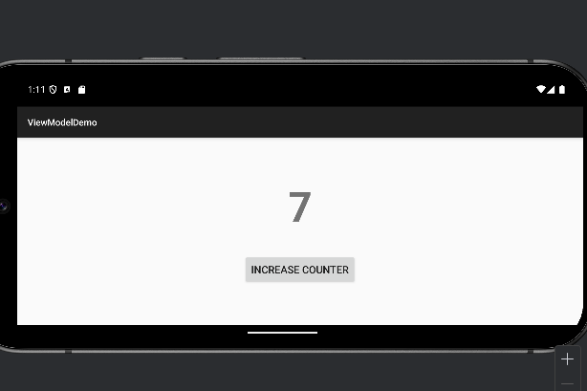

Department of CSE-IOT

Vision of the Department
To be a preferred hub for nurturing computer engineering aspirants through innovative, ethical, value-based technical education, impactful research, and industry collaboration, to become successful professionals contributing for the betterment of society.

Mission of the Department
To nurture computer engineering professionals by offering: Dynamic learning environment that encourages problem-solving using emerging technology, · National Education Policy aligned evidence-based technical education, fostering innovation, research, and industry–institute
collaboration, Holistic, ethical and sustainable development for lifelong success.

Output Analysis | The Android application successfully displays a counter value on the screen. When the user clicks the Increase Counter button, the counter value increments. The value is stored using ViewModel and LiveData, so when the device screen rotates, the counter remains unchanged and continues from the previous value. This demonstrates proper handling of configuration changes without data loss.
Link of student Github profile  where lab assignme nt has been uploaded | https://github.com/23071016/MWIOT-.git
Conclusi on | Program executed successfully.
Plag Report (Similarit y index < 12%) | 

Department of CSE-IOT

Vision of the Department
To be a preferred hub for nurturing computer engineering aspirants through innovative, ethical, value-based technical education, impactful research, and industry collaboration, to become successful professionals contributing for the betterment of society.

Mission of the Department
To nurture computer engineering professionals by offering: Dynamic learning environment that encourages problem-solving using emerging technology, · National Education Policy aligned evidence-based technical education, fostering innovation, research, and industry–institute
collaboration, Holistic, ethical and sustainable development for lifelong success.

Date | 4/2/2026

